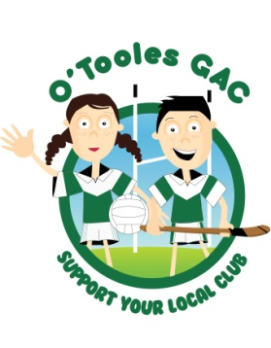

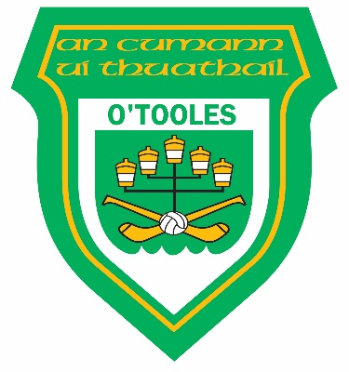

Easter Camp 2016

Tuesday 22nd to Thursday 24th March

Only €20 per Child

FOOTBALL & HURLING

Boys & Girls

Junior infants to 6th Class

10am to 2pm each day

**************************************************************

REGISTER IN O’Toole’s on Saturday 12 March 9:30 to 11am

******************************************************

For Information or Booking call David on 086 3101034 or

Kelly 085 1600381
Forms can also be returned to Club office 01 8482641

What to bring: Packed lunch with drink.
Helmet, Hurley & Mouth guard (if owned)
Appropriate playing gear ie: Tracksuit/shorts. Football boots/runners.
In the event of poor weather, it is advised to have a change of clothing.

LAST DATE FOR REGISTRATION IS FRIDAY 18th MARCH

